CMPEN454

Project 2

Team Members: SONGYANG MAO, ZERUI LI, JIAFU CHEN, HONGSHUO WANG

**Summary:**

The goal of this project is to work on the implementation of the camera projection from 3D point to 2D point and inverse which from 2D point to 3D point and also triangulation and some matrix transformation. Doing this project let us have a clear understanding of 2D image coordinates and 3D world coordinates and the chain of transformations that make up the pinhole camera model. We create many different Matlab function in order to finish the task such as projecting 3D points into 2D pixel locations, triangulation back into a set of 3D scene point, reconstruction of 3D locations by triangular from two camera views, measure the 3D construction error and computing epistolary lines between the two views. All these team-work we have done not only enrich the experience in Matlab programming but also let us have a deeper understanding of the knowledge in the field of 3D and 2D image.

**Procedural Approach:**

In this project, we choose every camera parameter in the data for completing the task that the project description asked for because each of these data are helpful for us to design our code and then achieve with the goals for convert 3D points to 2D camera pixel, and then covert 2D camera pixel to 3D rays and plot with the Epipolar 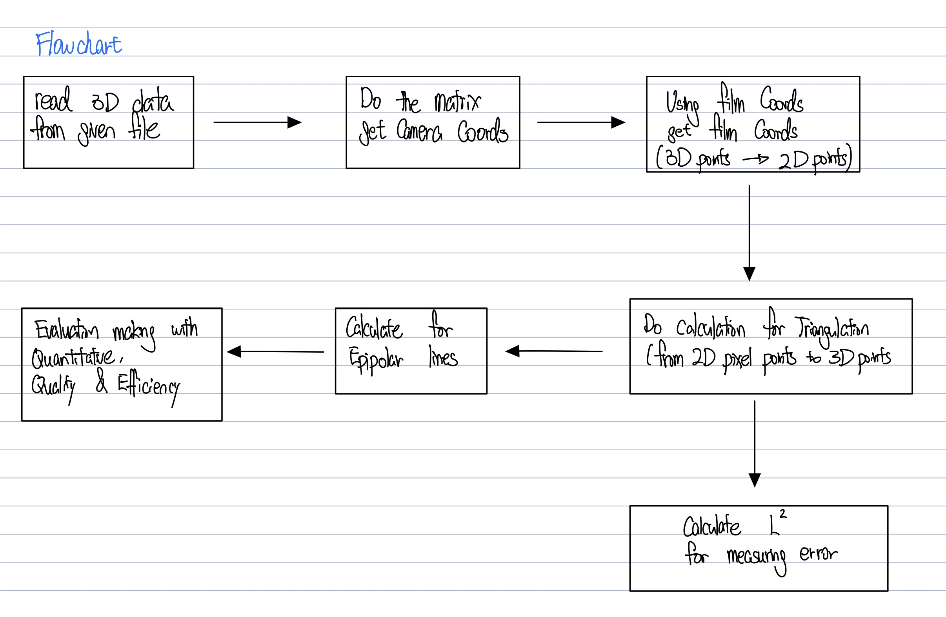lines.

Answers to section 2.2:

Q: Which are the internal parameters?

A: Internal parameters including focal length, offset, and pinpoint

Q: Which are the external parameters?

A: External parameters including Rmat and the position vector

Q: Which internal parameters combine to form the matrix Kmat?

A: Internal parameters combine to form Kmat are focal lengths and the offset.

Q: Which external parameters combine to form the matrix Pmat?

A: External parameters combine to form the matrix Pmat are Rmat with another row multiplied with position vector with another column

Q: What is the location of the camera?

A: The location of the camera could be defined as the Pc = RPw.

Checking for correctness:

Foe vue2, the Pc = RPw = [137.715365606944; 805.522696238255; 7336.52052400539] with is the 4th column for vue2.Pmat, and Pw = R’ Pc = [-4.4501e+03, 5.558e+03, 1.949e+03]which is the position for vue2.

For vue4, the Pc = RPw = [388.768652422159; 295.060869156745; 7283.00415138530] with is the 4th column for vue4.Pmat, and Pw = R’ Pc = [4.424e+03,5.4904e+03,1.889e+03] which is the position for vue4.

Hence, such calculation is correct.

Steps introduction:

* From 3D points to 2D pixel points

In this part, we basically using the equation given from Camera Projection lecture, compute 2D pixel coordinates with Homogeneous Coordinates, as follows: 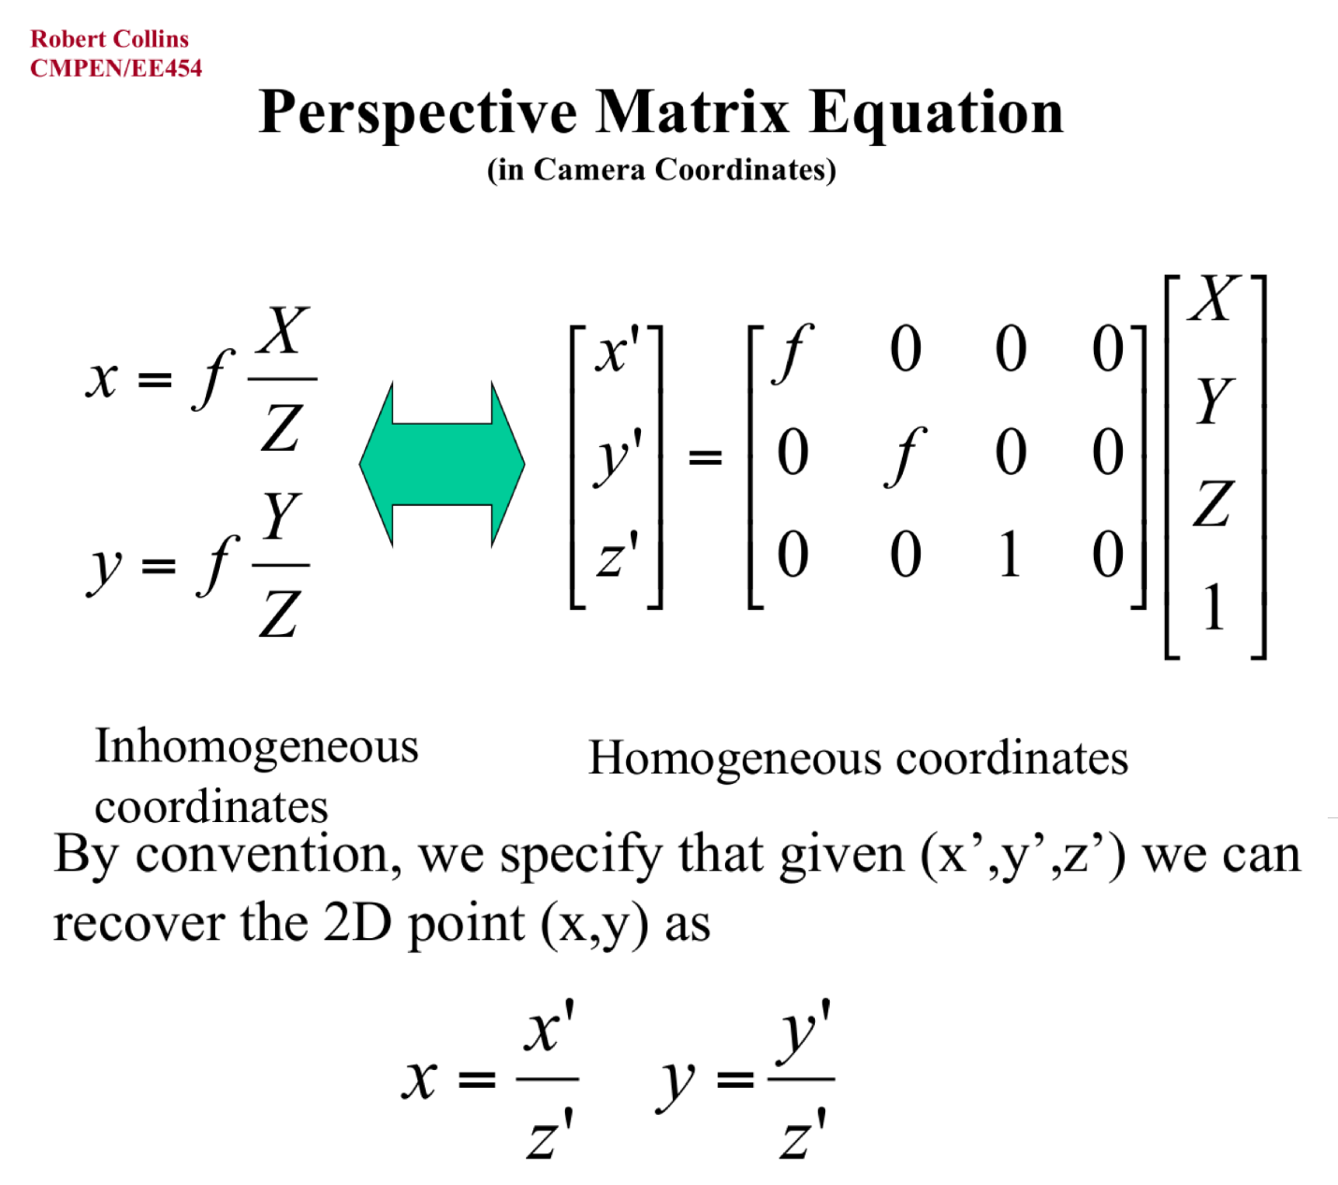

We used Kmat * Pmat * [x,y,z,1]T to get [x’,y’,z’]T, and then using such to get x and y for each points for camera vue2 and vue4.

* From 2D points to 3D points

In this part, we basically using the equation given from Triangulation lecture, compute 3D pixel with Solution from T&V Book.

we using the method on the last page of lecture 14 slides get a,b,d and u3. Then, we using the equation from former slides get Triangulation, T. Based on that, we grated the 3D points that build from our 2D pixel points from 2.3

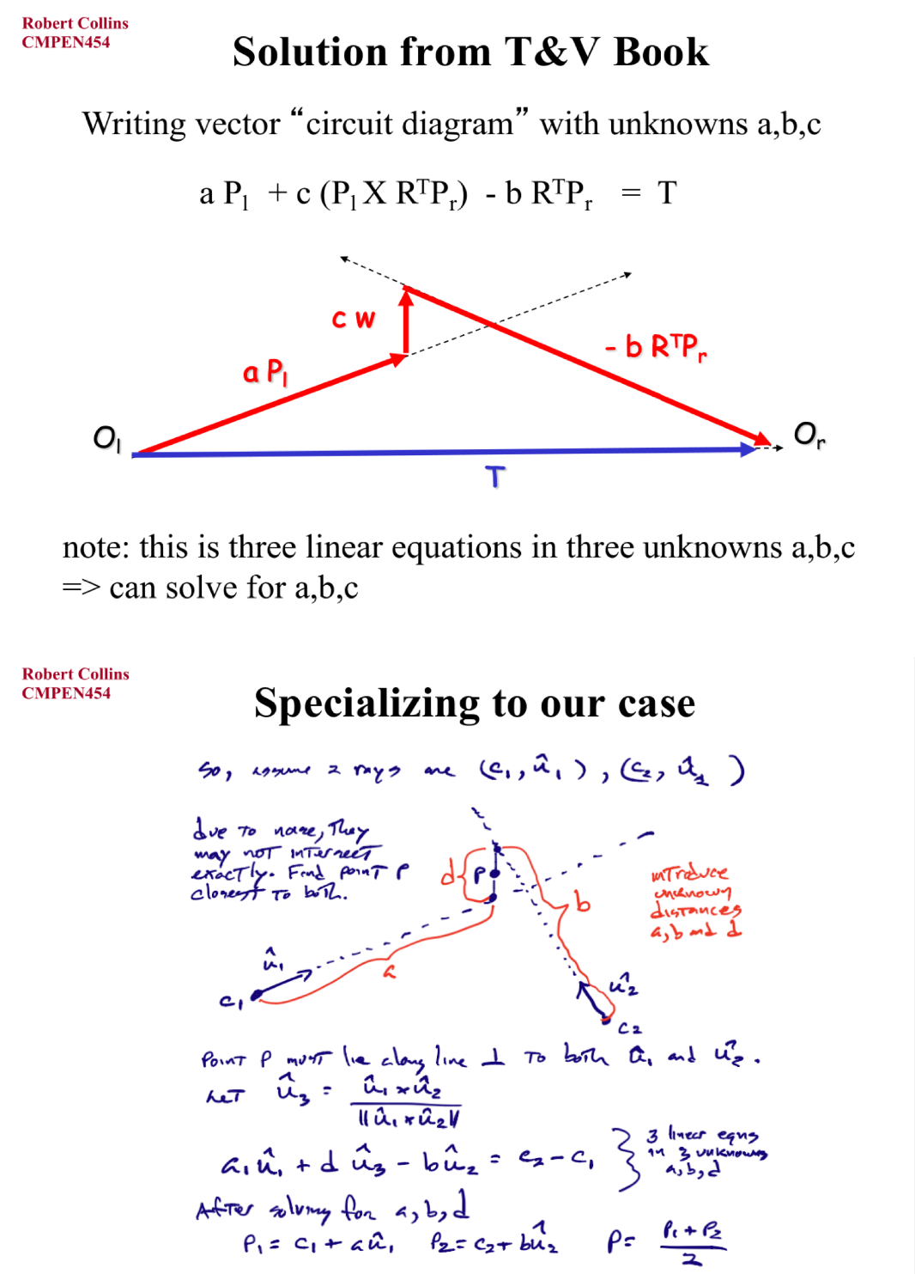

* Measure error between triangulated and original 3D points

In this part, we compute L2 (Euclidean) distance between our reconstructed 3D points and the original set of 3D points. Equation for L2 distance we compute is L2 = sqrt((X-X’)2 + (Y-Y’)2 + (Z-Z’)2).

* Computing Epipolar lines between the two views

In this part, we used the equation given from lecture slides to compute the epipolar lines for each graph of vue2 and vue4, the equation as follow: 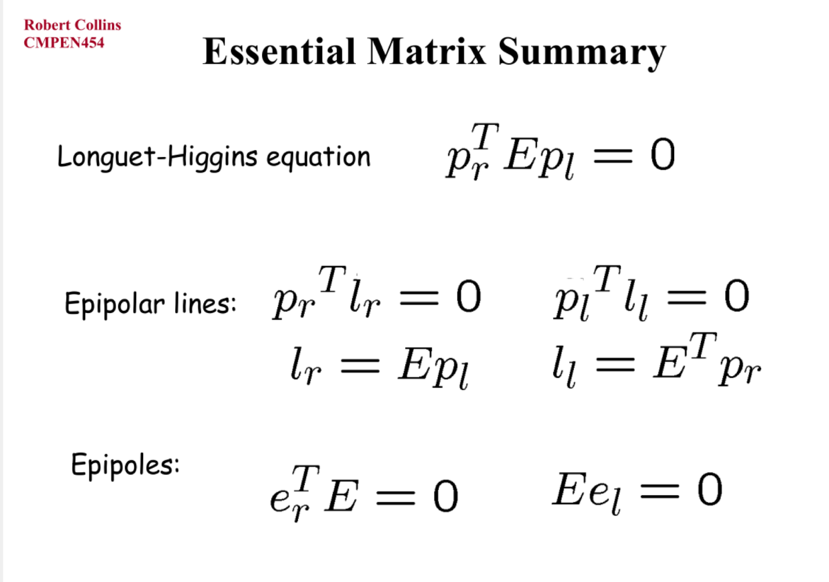

* Evaluation

In this part, we create an Evaluation Matrix for each of the twelve joint pairs, and create an Evaluation Matrix for all of the twelve joint pairs. We using a loop to do the 3D-2D and 2D-3D work, and for each iteration, we storage the data for the error of original 3D points and our restore 3D points. Then, we analysis the data by Evaluation Matrix for each of the twelve joint pairs, and Evaluation Matrix for all of the twelve joint pairs. Finally, we calculate error sums per frame using the data from the iterations of the loop.

Here is the detailed code:

We first create two variable firstIte and lastIte, meaning the first and last of the frame that we analyzed. Mark the iterations = 0 before the loop, as 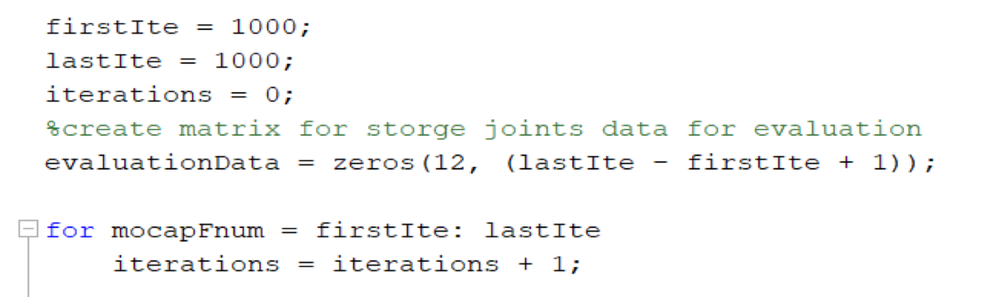

the loop iteration one more time, iterations += 1. Create the matrix evaluationData for evaluate our 3D error.

At the end of the loop, after we get the error as 3*12, store it on the evaluationData with index of iterations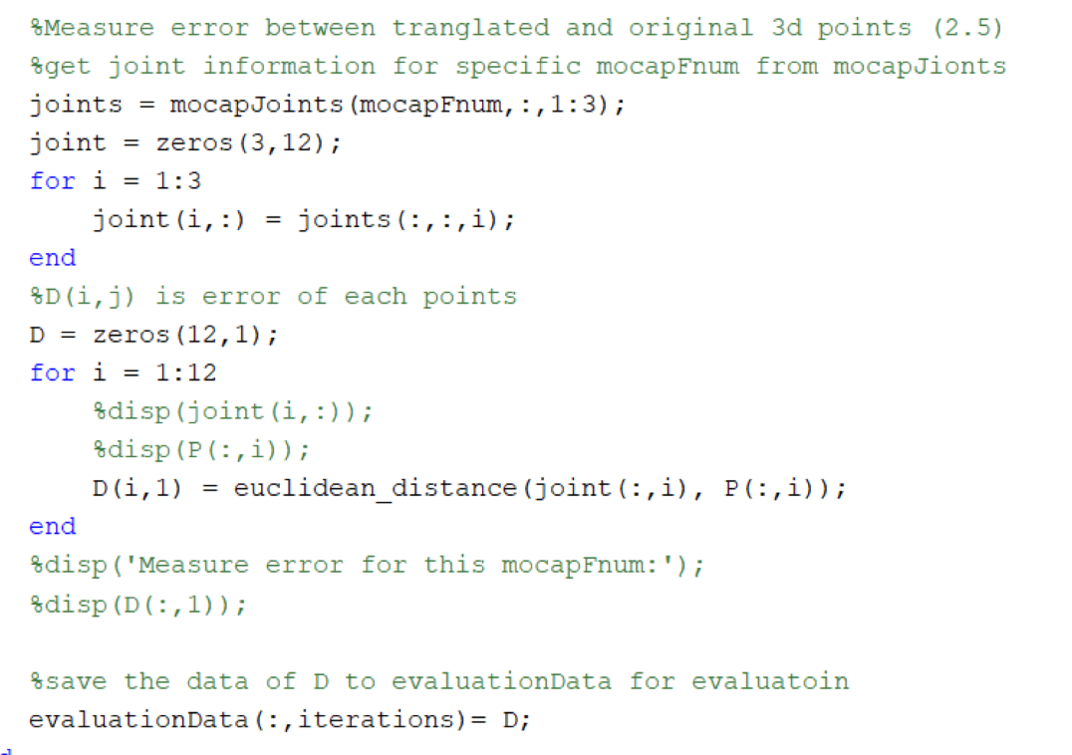

Then, we could get the error for each frame from each column of the evaluationData. 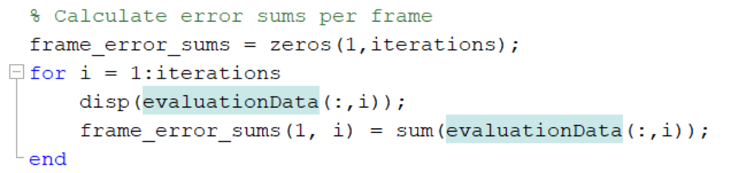

**Experimental Observation:**

The performance of our project’s code quite good. The running is very smooth as the way we design it to operate.

We test on different frame and here is the few outputs.

***The blue dot is each joint’s 2D

-mocapFnum = 1000

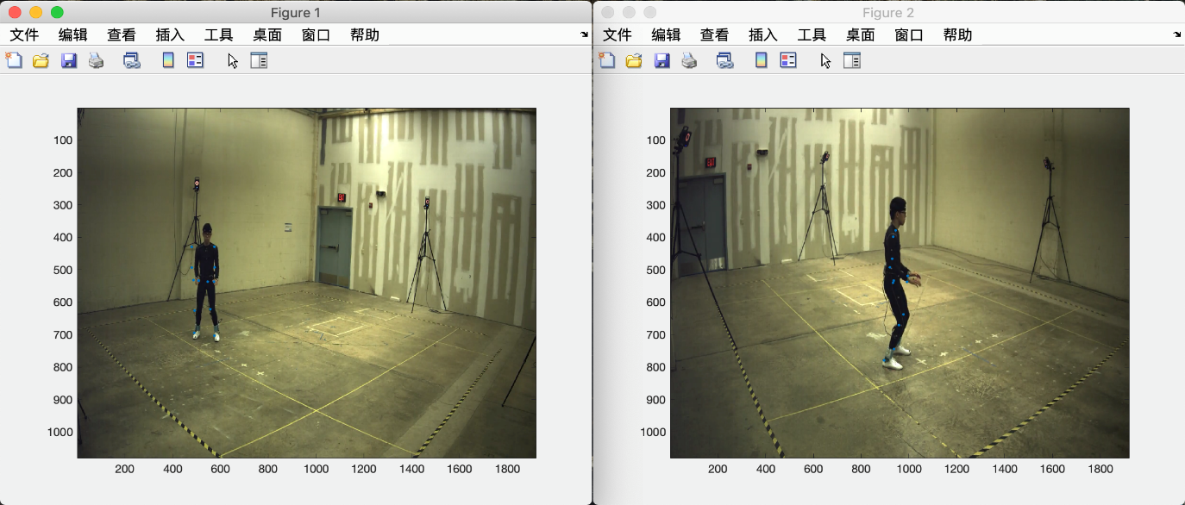

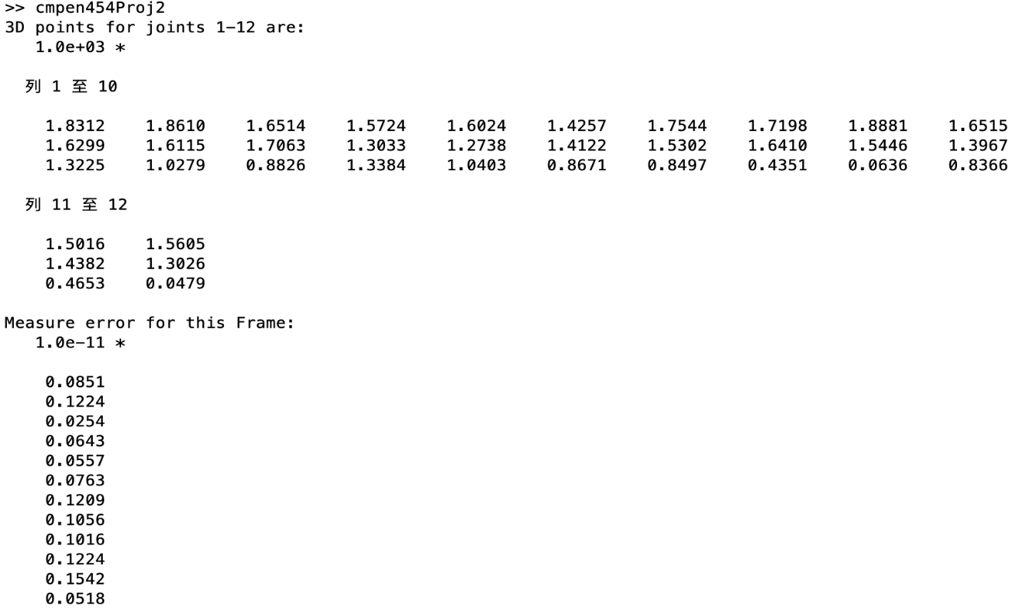

-mocapFnum=2000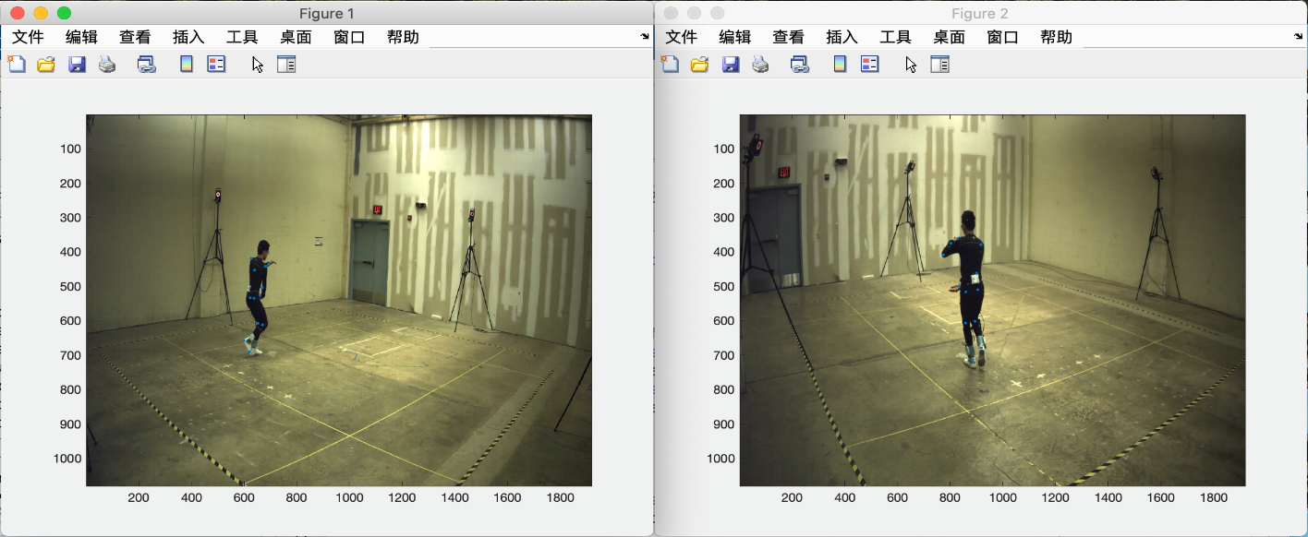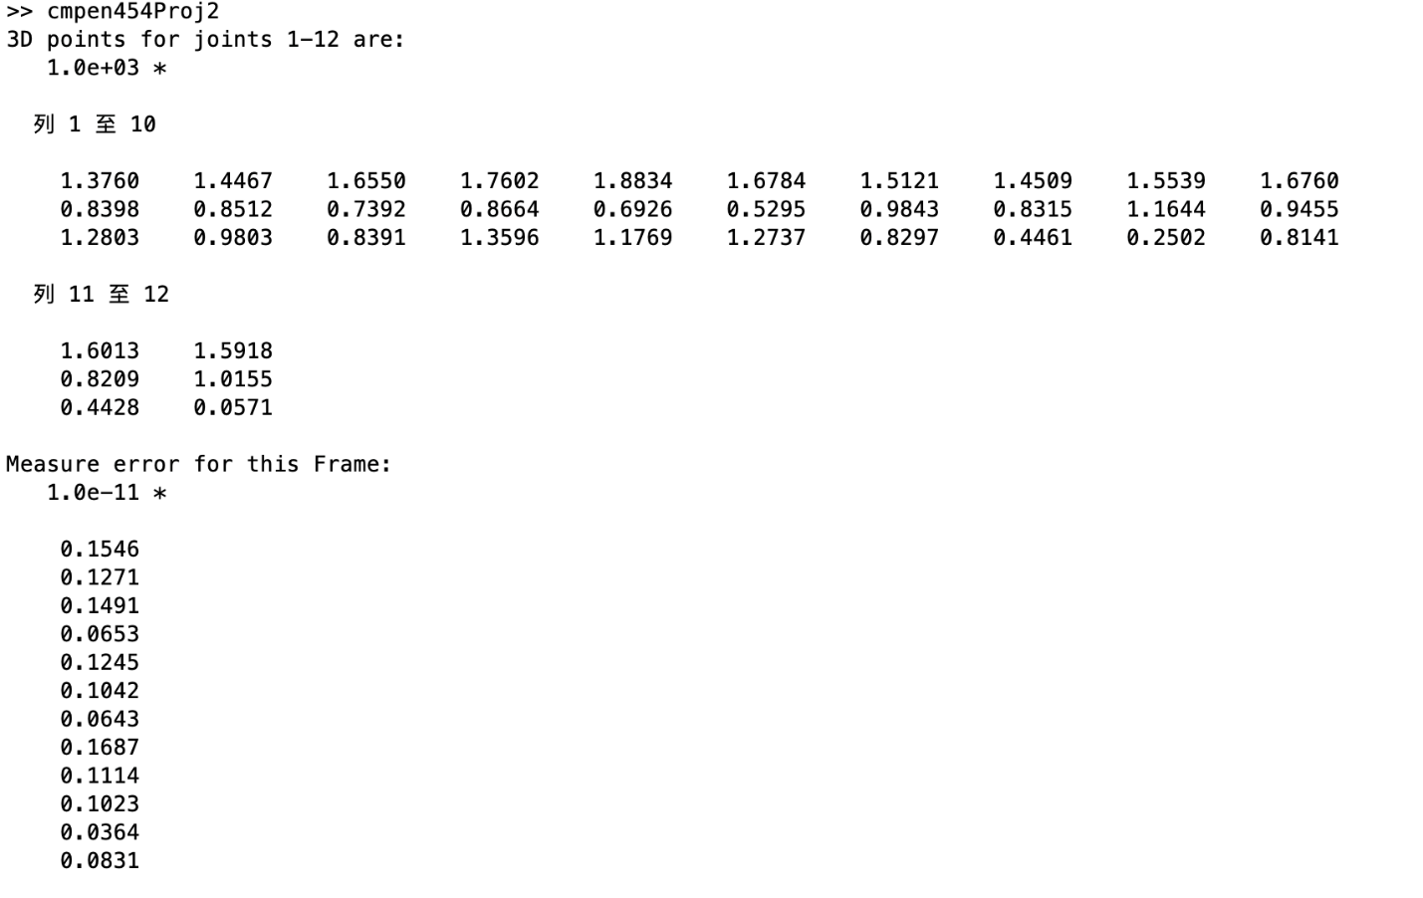

-mocapFnum=3000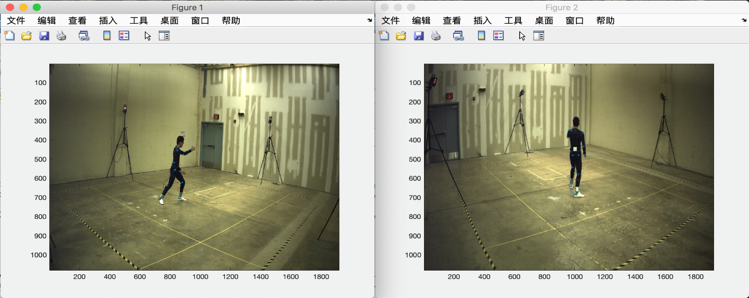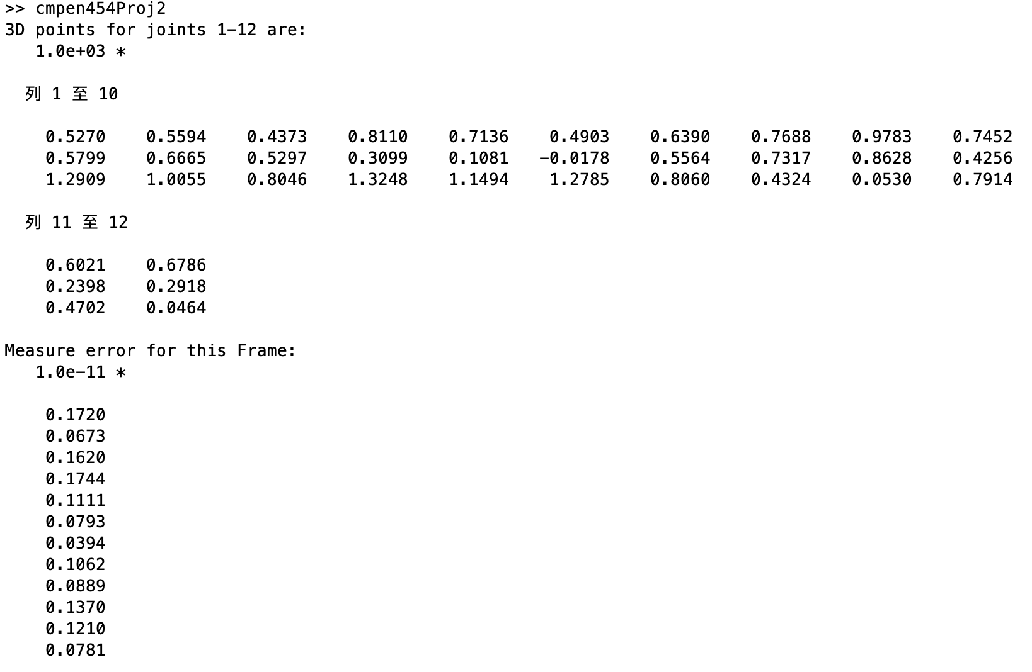

-mocapFnum = 4000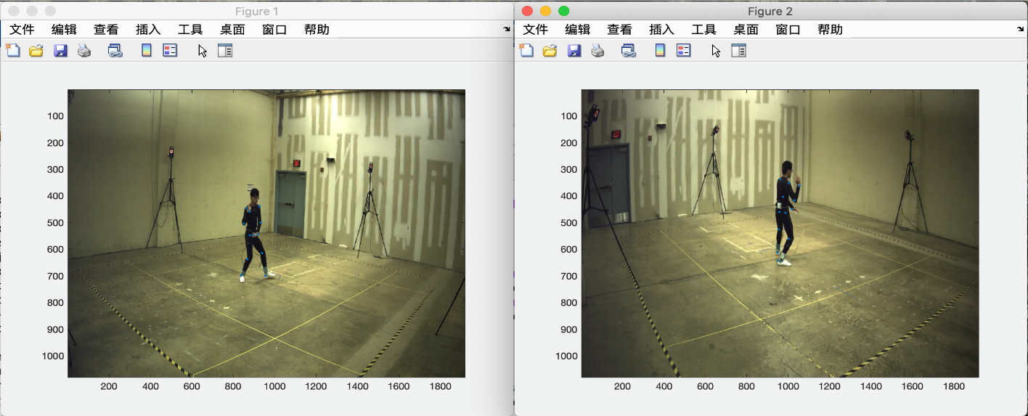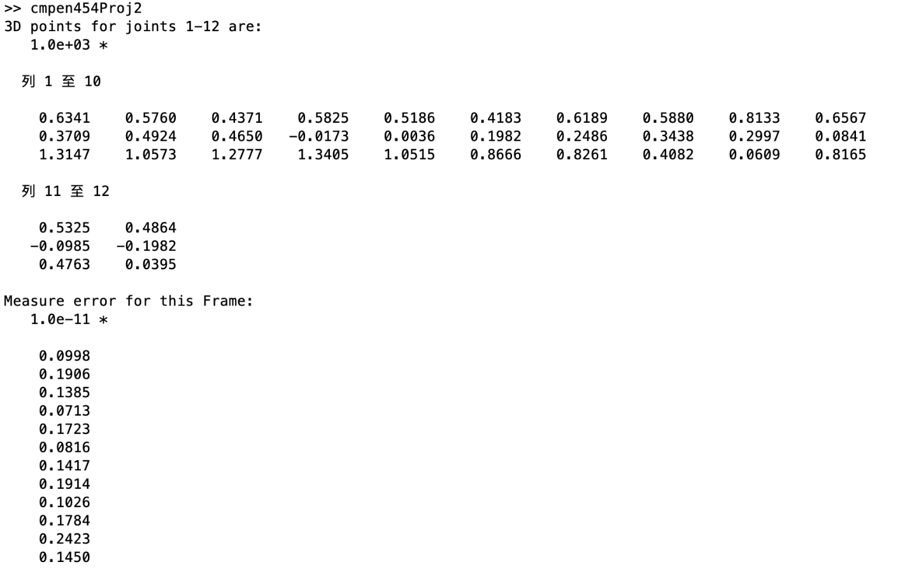

As the above four outputs show, the error for the frame is very small.

**Quantitative Results & Plot of total error 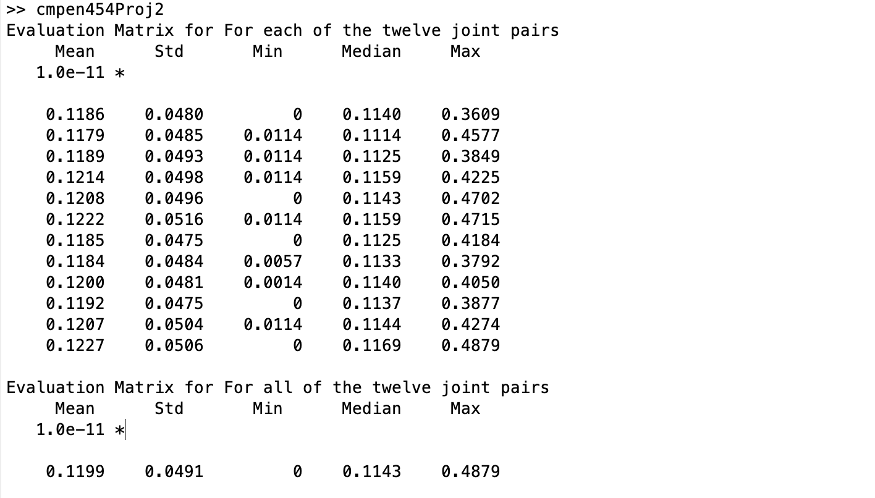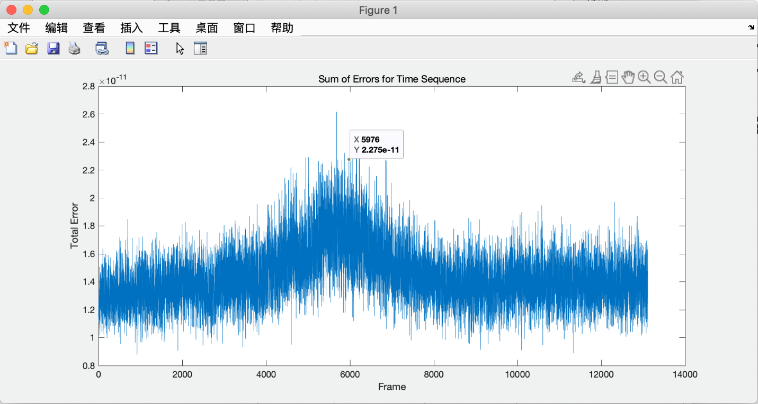The Plot Sum of Errors over 13106 frames shown that there has a peak around 5000-6000th frames over all of the frames in this dataset.**

**Qualitative Results:**

***The red dots that shows on the Figure is not the pixels of the joints. It is only use for the analyze and mark the body of this people.

- mocapFnum = 1000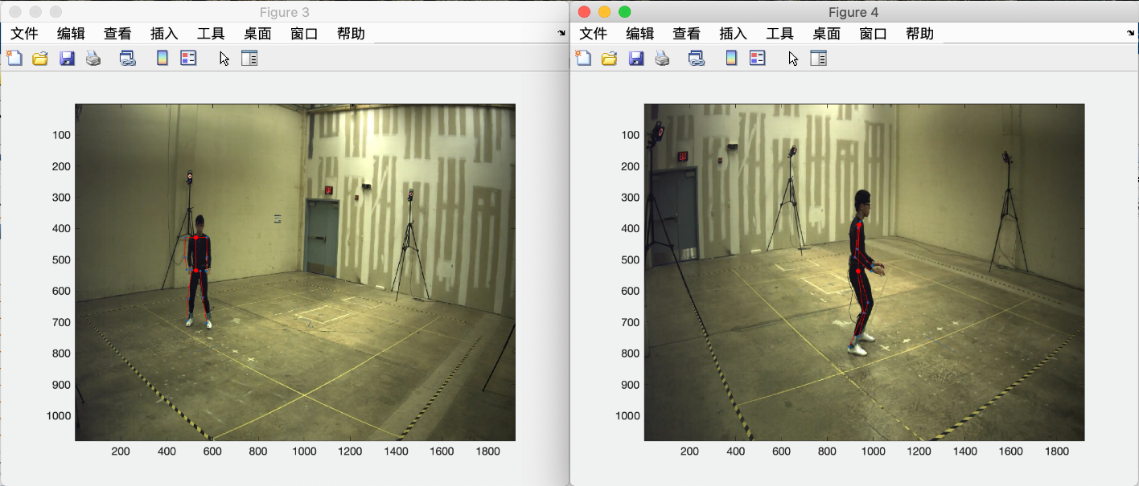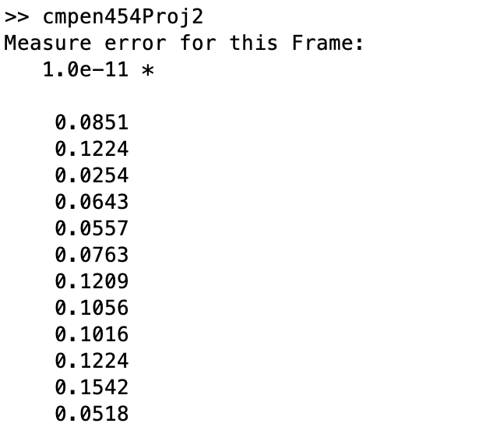

- mocapFnum = 2000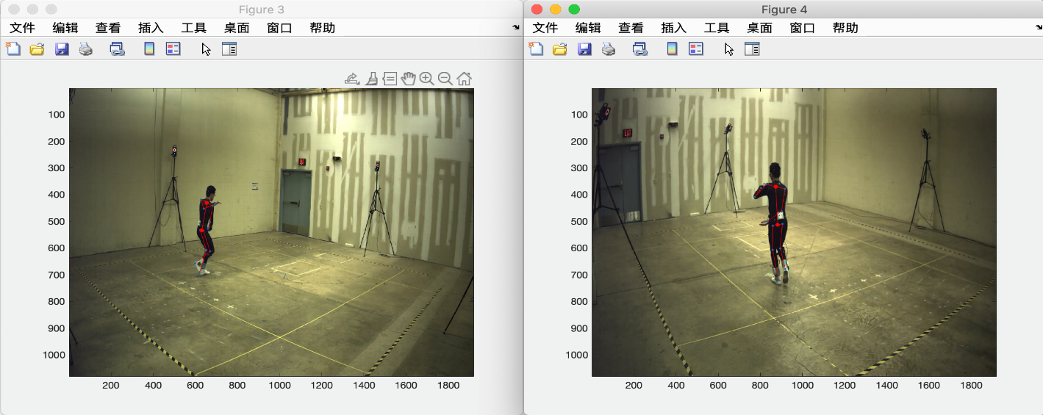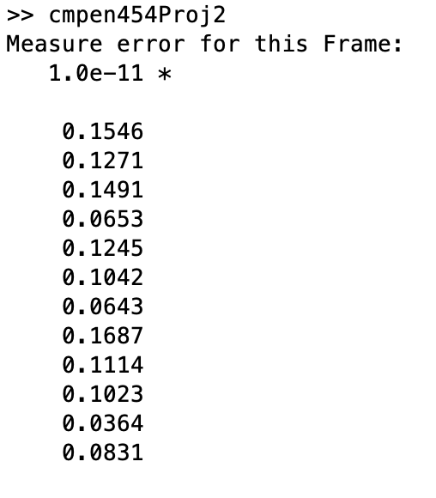

- mocapFnum = 3000

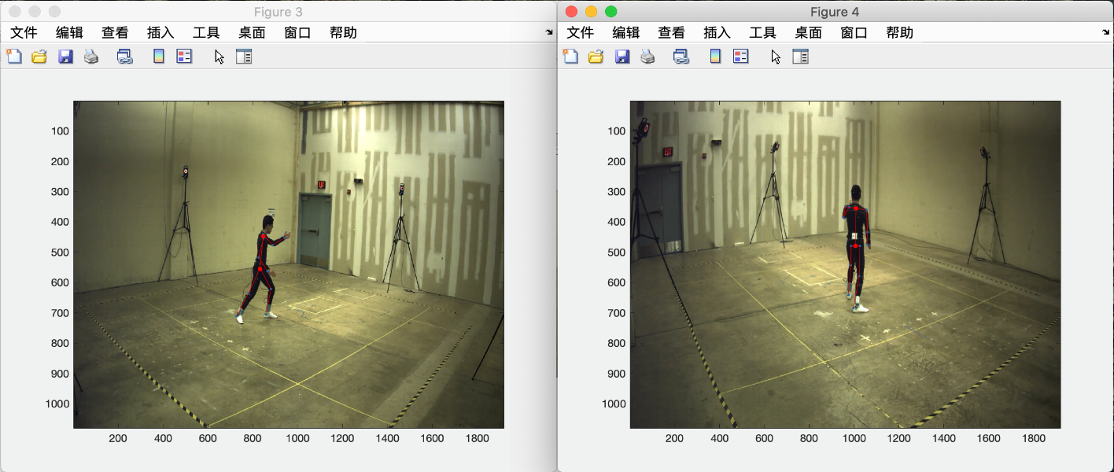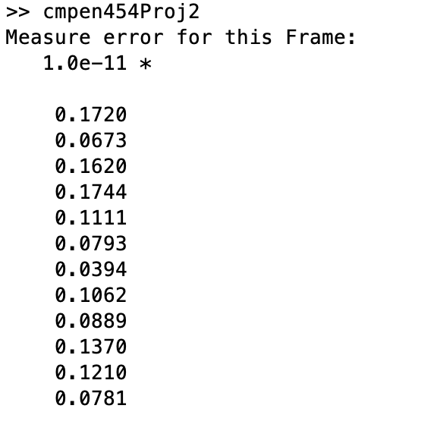

- mocapFnum = 4000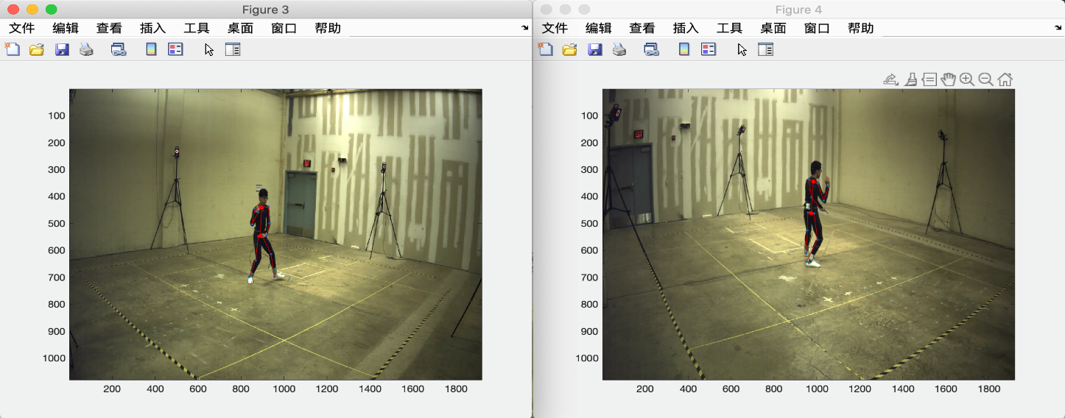 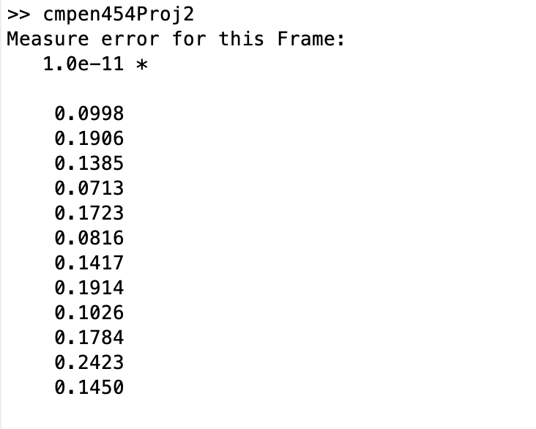

**Algorithm Efficiency:**

This is the Matlab profiler output. Showing the performance and the efficiency of our functions. It took quite amount of time to produce the outputs since we run every mocapFnums for doing this report. 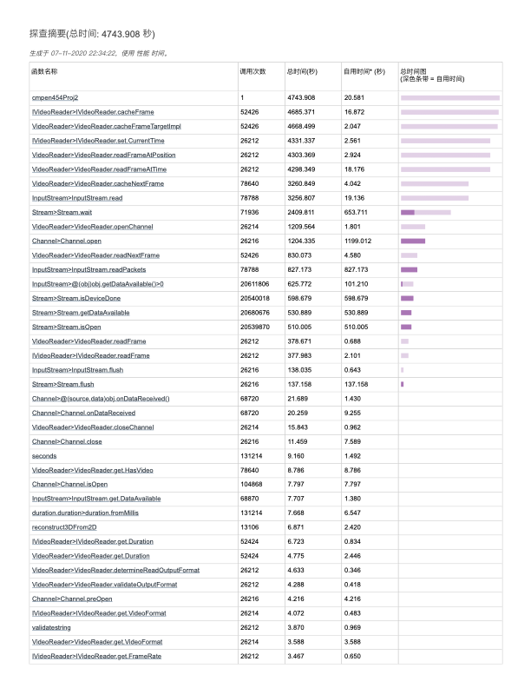

**Two-View epipolar:**

- mocapFnum =1000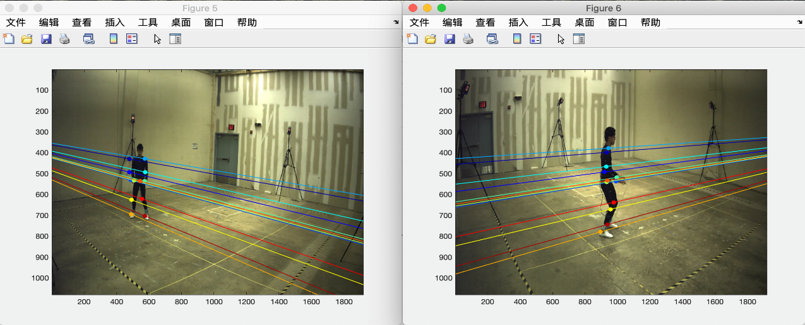

- mocapFnum =2000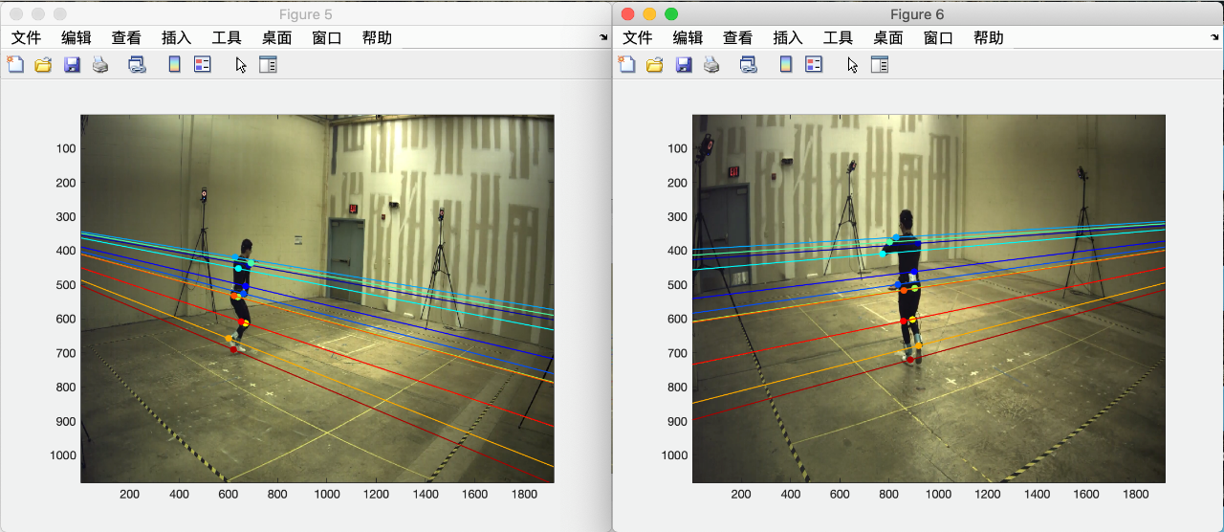 -mocapFnum = 3000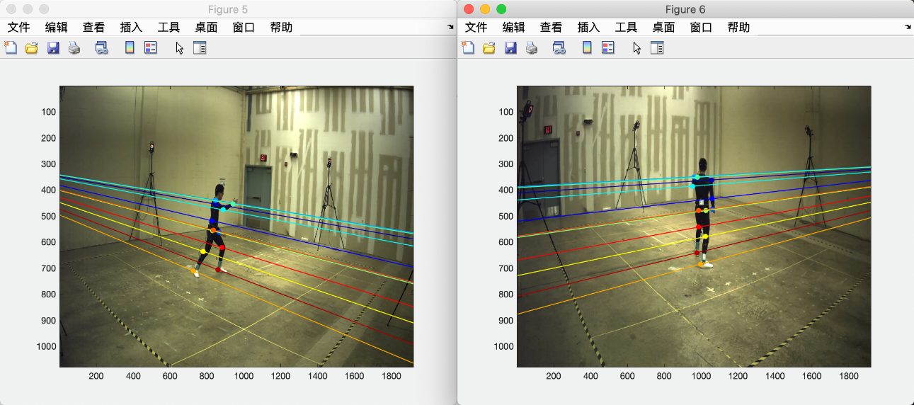

- mocapFnum = 4000

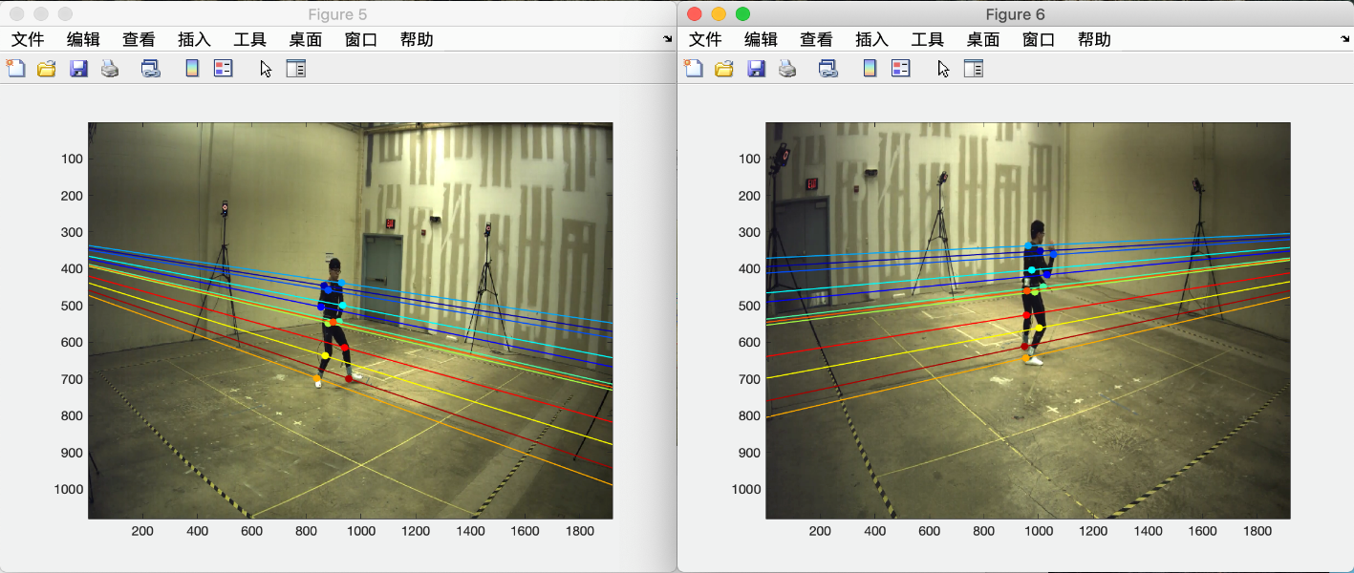

* The way we generate the epipolar lines

In this part, we used the equation given from lecture slides to compute the epipolar lines for each graph of vue2 and vue4, the equation as follow:

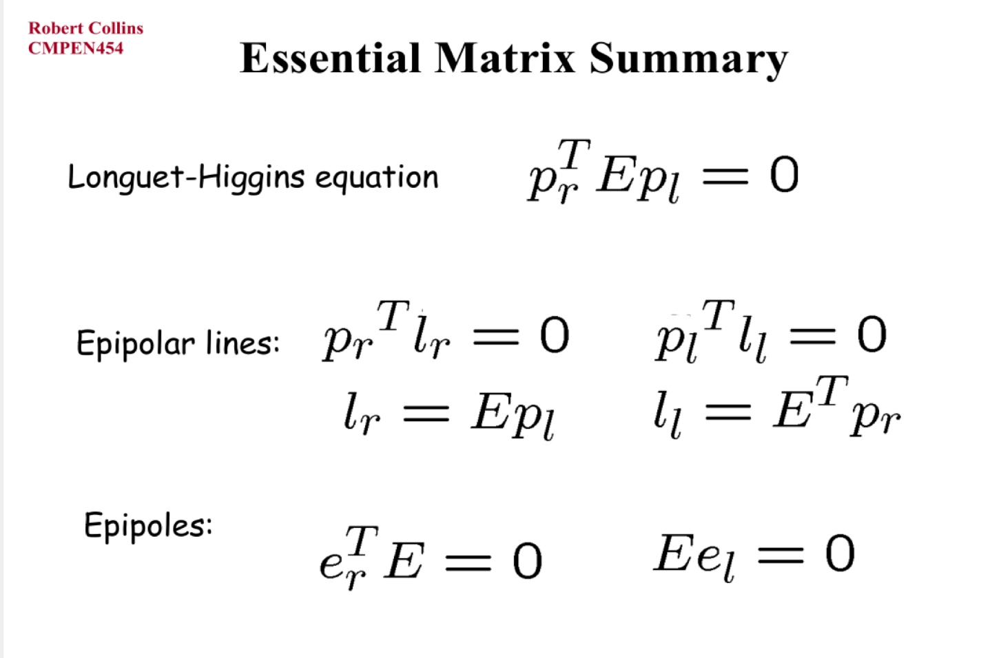

**Contribution:**

|  | Task Done |
| --- | --- |
| SONGYANG MAO | Test and Run the Matlab Code.  Monitor the performance of the running of the code, screen-shot the output figure and writing the report. |
| ZERUI LI | Whole structure of the program, part 2.3 Projecting 3D points into 2D pixel locations, part 2.6 Computing Epipolar lines between the two views, part 3 Program evaluations |
| HONGSHUO WANG | part 2.4 Triangulation back into a set of 3D scene points, part 2.5 Measure error between triangulated and original 3D points, part 2.6 Computing Epipolar lines between the two views |
| JIAFU CHEN | Part of the Project Report, code debugging |